# Daniel Rauscher

# Module 4 Assignment 2

drug <- read_csv("drug_data-1.csv")

##   
## ── Column specification ────────────────────────────────────────────────────────  
## cols(  
## .default = col_character(),  
## Column1 = col_double(),  
## Column2 = col_double(),  
## Column3 = col_double(),  
## Column4 = col_double(),  
## Column5 = col_double(),  
## Column6 = col_double(),  
## Column7 = col_double(),  
## Column8 = col_double(),  
## Column9 = col_double(),  
## Column10 = col_double(),  
## Column11 = col_double(),  
## Column12 = col_double(),  
## Column13 = col_double()  
## )  
## ℹ Use `spec()` for the full column specifications.

names(drug) = c("ID", "Age", "Gender", "Education", "Country", "Ethnicity",  
"Nscore", "Escore", "Oscore", "Ascore", "Cscore", "Impulsive",  
"SS", "Alcohol", "Amphet", "Amyl", "Benzos", "Caff", "Cannabis",  
"Choc", "Coke", "Crack", "Ecstasy", "Heroin", "Ketamine", "Legalh",  
"LSD", "Meth", "Mushrooms", "Nicotine", "Semer", "VSA")  
# str(drug)

drug[drug == "CL0"] = "No"  
drug[drug == "CL1"] = "No"  
drug[drug == "CL2"] = "Yes"  
drug[drug == "CL3"] = "Yes"  
drug[drug == "CL4"] = "Yes"  
drug[drug == "CL5"] = "Yes"  
drug[drug == "CL6"] = "Yes"

drug_clean = drug %>% mutate_at(vars(Age:Ethnicity), funs(as_factor)) %>%  
mutate(Age = factor(Age, labels = c("18_24", "25_34", "35_44",  
"45_54", "55_64", "65_"))) %>%  
mutate(Gender = factor(Gender, labels = c("Male", "Female"))) %>%  
mutate(Education = factor(Education, labels =  
c("Under16", "At16", "At17", "At18", "SomeCollege",  
"ProfessionalCert", "Bachelors", "Masters", "Doctorate"))) %>%  
mutate(Country = factor(Country,  
labels = c("USA", "NewZealand", "Other", "Australia",  
"Ireland","Canada","UK"))) %>%  
mutate(Ethnicity = factor(Ethnicity,  
labels = c("Black", "Asian", "White", "White/Black", "Other",  
"White/Asian", "Black/Asian"))) %>%  
 mutate_at(vars(Alcohol:VSA), funs(as_factor)) %>%  
select(-ID)

## Warning: `funs()` is deprecated as of dplyr 0.8.0.  
## Please use a list of either functions or lambdas:   
##   
## # Simple named list:   
## list(mean = mean, median = median)  
##   
## # Auto named with `tibble::lst()`:   
## tibble::lst(mean, median)  
##   
## # Using lambdas  
## list(~ mean(., trim = .2), ~ median(., na.rm = TRUE))  
## This warning is displayed once every 8 hours.  
## Call `lifecycle::last_warnings()` to see where this warning was generated.

# str(drug_clean)

drug_clean = drug_clean %>% select(!(Alcohol:Mushrooms)) %>% select(!(Semer:VSA))  
names(drug_clean)

## [1] "Age" "Gender" "Education" "Country" "Ethnicity" "Nscore"   
## [7] "Escore" "Oscore" "Ascore" "Cscore" "Impulsive" "SS"   
## [13] "Nicotine"

## Task 1

After running the skim on the data and visualizing any missing data, it does not appear there is any missing data.

skim(drug_clean)

Data summary

|  |  |
| --- | --- |
| Name | drug_clean |
| Number of rows | 1885 |
| Number of columns | 13 |
| _______________________ |  |
| Column type frequency: |  |
| factor | 6 |
| numeric | 7 |
| ________________________ |  |
| Group variables | None |

**Variable type: factor**

|  |  |  |  |  |  |
| --- | --- | --- | --- | --- | --- |
| skim_variable | n_missing | complete_rate | ordered | n_unique | top_counts |
| Age | 0 | 1 | FALSE | 6 | 18_: 643, 25_: 481, 35_: 356, 45_: 294 |
| Gender | 0 | 1 | FALSE | 2 | Mal: 943, Fem: 942 |
| Education | 0 | 1 | FALSE | 9 | Som: 506, Bac: 480, Mas: 283, Pro: 270 |
| Country | 0 | 1 | FALSE | 7 | UK: 1044, USA: 557, Oth: 118, Can: 87 |
| Ethnicity | 0 | 1 | FALSE | 7 | Whi: 1720, Oth: 63, Bla: 33, Asi: 26 |
| Nicotine | 0 | 1 | FALSE | 2 | Yes: 1264, No: 621 |

**Variable type: numeric**

|  |  |  |  |  |  |  |  |  |  |  |
| --- | --- | --- | --- | --- | --- | --- | --- | --- | --- | --- |
| skim_variable | n_missing | complete_rate | mean | sd | p0 | p25 | p50 | p75 | p100 | hist |
| Nscore | 0 | 1 | 0.00 | 1.00 | -3.46 | -0.68 | 0.04 | 0.63 | 3.27 | ▁▃▇▅▁ |
| Escore | 0 | 1 | 0.00 | 1.00 | -3.27 | -0.70 | 0.00 | 0.64 | 3.27 | ▁▃▇▃▁ |
| Oscore | 0 | 1 | 0.00 | 1.00 | -3.27 | -0.72 | -0.02 | 0.72 | 2.90 | ▁▃▇▆▁ |
| Ascore | 0 | 1 | 0.00 | 1.00 | -3.46 | -0.61 | -0.02 | 0.76 | 3.46 | ▁▃▇▃▁ |
| Cscore | 0 | 1 | 0.00 | 1.00 | -3.46 | -0.65 | -0.01 | 0.58 | 3.46 | ▁▃▇▃▁ |
| Impulsive | 0 | 1 | 0.01 | 0.95 | -2.56 | -0.71 | -0.22 | 0.53 | 2.90 | ▁▆▇▃▁ |
| SS | 0 | 1 | 0.00 | 0.96 | -2.08 | -0.53 | 0.08 | 0.77 | 1.92 | ▂▇▇▇▅ |

gg_miss_case(drug_clean)

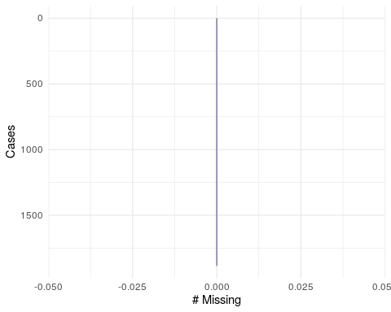

## Task 2

set.seed(1234)  
drug_split = initial_split(drug_clean, prop = 0.7, strata = Nicotine)   
train = training(drug_split)  
test = testing(drug_split)

## Task 3

Most of the variables in this data set seem to correlate with Nicotine. The variables that appear correlated with Nicotine are age, gender, country, education, ethnicity, nscore, oscore, ascore, cscore, impulsive and SS. Some of these variables are intuitive, like Impulsive scores that are lower tend to be tied to less nicotine, and the older you are the less likely you are to smoke because the effects could be more deadly than for a younger person.

p1 = ggplot(train, aes(x = Age, fill = Nicotine)) + geom_bar(position = "fill")+ theme(axis.text.x = element_text(angle = 45, hjust=1))  
p2 = ggplot(train, aes(x = Gender, fill = Nicotine)) + geom_bar(position = "fill")  
p3 = ggplot(train, aes(x = Education, fill = Nicotine)) + geom_bar(position = "fill")+ theme(axis.text.x = element_text(angle = 45, hjust=1))  
p4 = ggplot(train, aes(x = Country, fill = Nicotine)) + geom_bar(position = "fill")+ theme(axis.text.x = element_text(angle = 45, hjust=1))  
p5 = ggplot(train, aes(x = Ethnicity, fill = Nicotine)) + geom_bar(position = "fill")+ theme(axis.text.x = element_text(angle = 45, hjust=1))  
grid.arrange(p1,p2,p3,p4,p5)

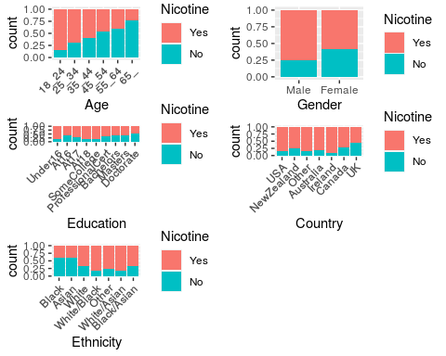

p1 = ggplot(train, aes(x = Nicotine, y = Nscore)) + geom_boxplot()  
p2 = ggplot(train, aes(x = Nicotine, y = Escore)) + geom_boxplot()  
p3 = ggplot(train, aes(x = Nicotine, y = Oscore)) + geom_boxplot()  
p4 = ggplot(train, aes(x = Nicotine, y = Ascore)) + geom_boxplot()  
grid.arrange(p1,p2,p3,p4, ncol = 2)

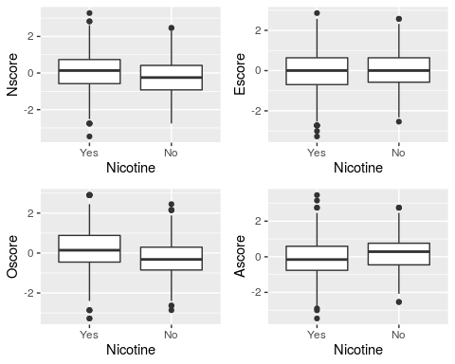

p1 = ggplot(train, aes(x = Nicotine, y = Cscore)) + geom_boxplot()  
p2 = ggplot(train, aes(x = Nicotine, y = Impulsive)) + geom_boxplot()  
p3 = ggplot(train, aes(x = Nicotine, y = SS)) + geom_boxplot()  
grid.arrange(p1,p2,p3, ncol = 2)

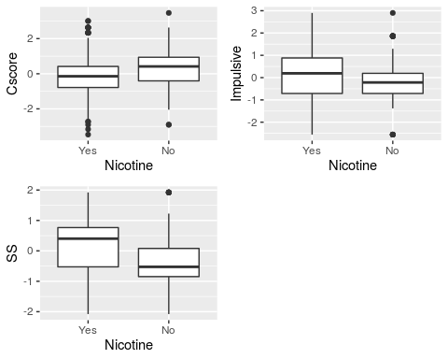

## Task 4

set.seed(123)  
rf_folds=vfold_cv(train, v=5)

drug_recipe = recipe(Nicotine ~., train) %>%  
 step_dummy(all_nominal(), -all_outcomes())  
  
rf_model = rand_forest(mtry = tune(), min_n = tune(), trees = 100) %>%   
 set_engine("ranger", importance = "permutation") %>%   
 set_mode("classification")  
  
drug_wflow =   
 workflow() %>%   
 add_model(rf_model) %>%   
 add_recipe(drug_recipe)  
  
rf_grid = grid_regular(  
 mtry(range = c(2, 8)),   
 min_n(range = c(5, 20)),   
 levels = 10)  
  
set.seed(123)  
rf_res_tuned = tune_grid(  
 drug_wflow,  
 resamples = rf_folds,  
 grid = rf_grid)

##   
## Attaching package: 'rlang'

## The following objects are masked from 'package:purrr':  
##   
## %@%, as_function, flatten, flatten_chr, flatten_dbl, flatten_int,  
## flatten_lgl, flatten_raw, invoke, list_along, modify, prepend,  
## splice

##   
## Attaching package: 'vctrs'

## The following object is masked from 'package:dplyr':  
##   
## data_frame

## The following object is masked from 'package:tibble':  
##   
## data_frame

rf_res_tuned %>%  
 collect_metrics() %>%  
 filter(.metric == "accuracy") %>%  
 select(mean, min_n, mtry) %>%  
 pivot_longer(min_n:mtry,  
 values_to = "value",  
 names_to = "parameter"  
 ) %>%  
 ggplot(aes(value, mean, color = parameter)) +  
 geom_point(show.legend = FALSE) +  
 facet_wrap(~parameter, scales = "free_x") +  
 labs(x = NULL, y = "Accuracy")

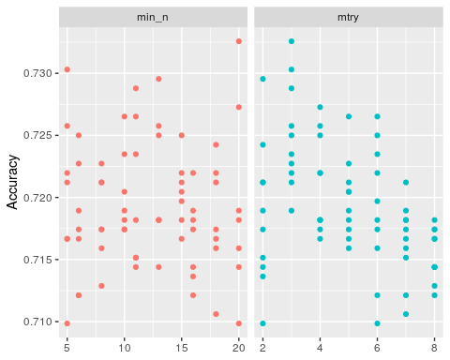

## Task 5

The most important variables in the model are SS (sensation), Country (Specifically the UK), Oscore (Openess to experience), and Age (specifically 45-54).

best_rf = select_best(rf_res_tuned, "accuracy")  
  
final_rf = finalize_workflow(drug_wflow, best_rf)  
  
final_rf

## ══ Workflow ════════════════════════════════════════════════════════════════════  
## Preprocessor: Recipe  
## Model: rand_forest()  
##   
## ── Preprocessor ────────────────────────────────────────────────────────────────  
## 1 Recipe Step  
##   
## ● step_dummy()  
##   
## ── Model ───────────────────────────────────────────────────────────────────────  
## Random Forest Model Specification (classification)  
##   
## Main Arguments:  
## mtry = 3  
## trees = 100  
## min_n = 20  
##   
## Engine-Specific Arguments:  
## importance = permutation  
##   
## Computational engine: ranger

final_rf_fit = fit(final_rf, train)  
  
final_rf_fit %>% pull_workflow_fit() %>% vip(geom = "point")

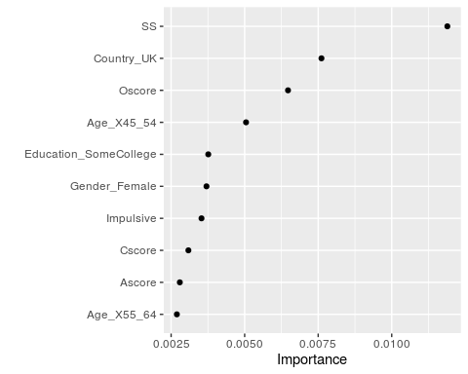

## Task 6

The accuracy on the training set is 85.15%, nearly 20% better than the naive model. The accuracy on the testing model is 71.33%, only 4% better than the naive model. This is a fairly big difference in the training and testing model accuracy %, which could mean the model will not perform well on new data.

trainpredrf = predict(final_rf_fit, train)  
head(trainpredrf)

## # A tibble: 6 x 1  
## .pred_class  
## <fct>   
## 1 Yes   
## 2 Yes   
## 3 Yes   
## 4 No   
## 5 Yes   
## 6 Yes

confusionMatrix(trainpredrf$.pred_class, train$Nicotine,  
 positive = "Yes")

## Confusion Matrix and Statistics  
##   
## Reference  
## Prediction Yes No  
## Yes 850 171  
## No 35 264  
##   
## Accuracy : 0.8439   
## 95% CI : (0.8232, 0.8631)  
## No Information Rate : 0.6705   
## P-Value [Acc > NIR] : < 2.2e-16   
##   
## Kappa : 0.6163   
##   
## Mcnemar's Test P-Value : < 2.2e-16   
##   
## Sensitivity : 0.9605   
## Specificity : 0.6069   
## Pos Pred Value : 0.8325   
## Neg Pred Value : 0.8829   
## Prevalence : 0.6705   
## Detection Rate : 0.6439   
## Detection Prevalence : 0.7735   
## Balanced Accuracy : 0.7837   
##   
## 'Positive' Class : Yes   
##

testpredrf = predict(final_rf_fit, test)  
head(testpredrf)

## # A tibble: 6 x 1  
## .pred_class  
## <fct>   
## 1 Yes   
## 2 No   
## 3 No   
## 4 Yes   
## 5 No   
## 6 Yes

confusionMatrix(testpredrf$.pred_class, test$Nicotine,  
 positive = "Yes")

## Confusion Matrix and Statistics  
##   
## Reference  
## Prediction Yes No  
## Yes 337 121  
## No 42 65  
##   
## Accuracy : 0.7115   
## 95% CI : (0.6722, 0.7486)  
## No Information Rate : 0.6708   
## P-Value [Acc > NIR] : 0.02111   
##   
## Kappa : 0.2676   
##   
## Mcnemar's Test P-Value : 9.999e-10   
##   
## Sensitivity : 0.8892   
## Specificity : 0.3495   
## Pos Pred Value : 0.7358   
## Neg Pred Value : 0.6075   
## Prevalence : 0.6708   
## Detection Rate : 0.5965   
## Detection Prevalence : 0.8106   
## Balanced Accuracy : 0.6193   
##   
## 'Positive' Class : Yes   
##

## Task 7

This model could be used the real world for advertising agencies. They could use this model to see which variables (demographics) to target with their marketing campaign to either promote cigarettes or dissuade potential users from smoking. I think this model could be used for advertising where the incorrect prediction might result in a slightly less successful advertising campaign. The accuracy on both models are still pretty high. However, I would not recommend this model if Dr’s were using it and predicing incorrectly had dire consequences.